A **maximum tree** is a tree where every node has a value greater than any other value in its subtree.

You are given the root of a maximum binary tree and an integer val.

Just as in the [previous problem](https://leetcode.com/problems/maximum-binary-tree/), the given tree was constructed from a list a (root = Construct(a)) recursively with the following Construct(a) routine:

* If a is empty, return null.
* Otherwise, let a[i] be the largest element of a. Create a root node with the value a[i].
* The left child of root will be Construct([a[0], a[1], ..., a[i - 1]]).
* The right child of root will be Construct([a[i + 1], a[i + 2], ..., a[a.length - 1]]).
* Return root.

Note that we were not given a directly, only a root node root = Construct(a).

Suppose b is a copy of a with the value val appended to it. It is guaranteed that b has unique values.

Return Construct(b).

**Example 1:**

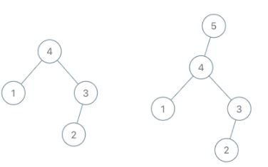

**Input:** root = [4,1,3,null,null,2], val = 5

**Output:** [5,4,null,1,3,null,null,2]

**Explanation:** a = [1,4,2,3], b = [1,4,2,3,5]

**Example 2:**

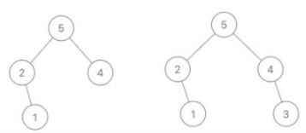

**Input:** root = [5,2,4,null,1], val = 3

**Output:** [5,2,4,null,1,null,3]

**Explanation:** a = [2,1,5,4], b = [2,1,5,4,3]

**Example 3:**

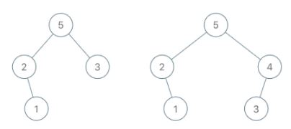

**Input:** root = [5,2,3,null,1], val = 4

**Output:** [5,2,4,null,1,3]

**Explanation:** a = [2,1,5,3], b = [2,1,5,3,4]

**Constraints:**

* The number of nodes in the tree is in the range [1, 100].
* 1 <= Node.val <= 100
* All the values of the tree are **unique**.
* 1 <= val <= 100